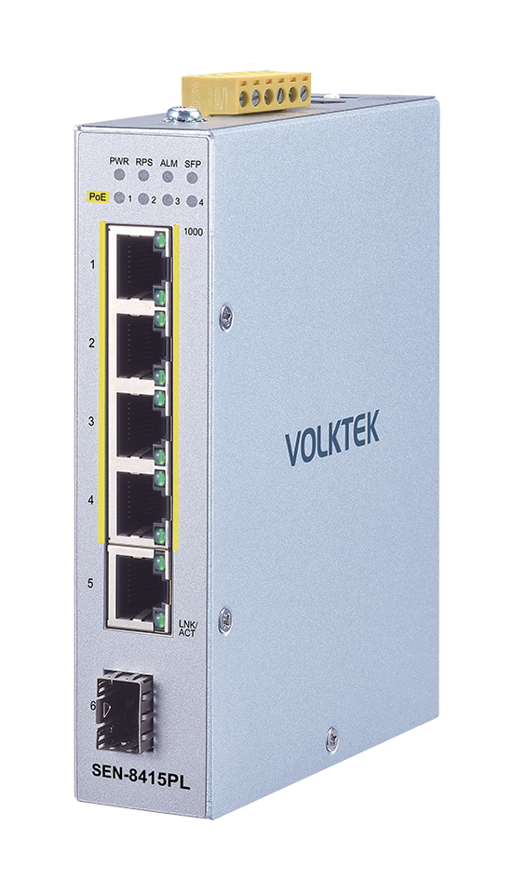
2024~2025 Volktek Product Catalog




SEN-8415PL
Lite Managed PoE+ Industrial Switch
4 x 10/100/1000 PoE+ & 1 x 10/100/1000 RJ45 &
1 x FX/GbE SFP

Description

The SEN-8415PL is a Lite Managed Industrial PoE+ Ethernet Switch perfectly suited in harsh environments and an ideal solution for easy managed surveillance systems. The switch is designed to meet the requirements of both power and data transmission over single Ethernet cable to PoE+ appliances and devices without the need for power outlets, eliminating additional cost of electrical cabling and circuits.
The switch’s case and hardened components withstand high degree of vibration, shock and wide operating temperatures from -10°C to 60°C. Switch features 5-port 10/100/1000BASE-T and 1-slot 100FX/Gigabit SFP to satisfy new and evolving network demands in longer distances via its fiber port. With 4 IEEE 802.3af/at compliant ports, each of them allows up to 30W to satisfy the growing demand of high power consuming network devices such as WLAN AP, VoIP phones and IP surveillance cameras, and other powered devices in long distances up to 100 meters with Cat5e cables or above.










In addition, the switch facilitates built-in basic software features such as Port-based priority, Loop Detection, Flow Control, Storm Control and other network management functions to deliver a rock solid, adjustable networks, to ensure impressive uptime even in the most challenging conditions.
IP Code
-10°C 60°C
40
PoE +
30W
Per Port
DIN Rail

Features Highlight

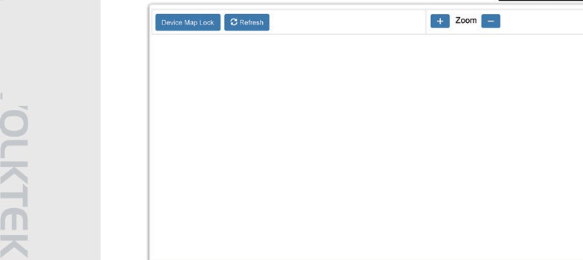
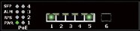
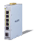
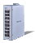
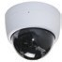
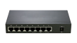
Introducing the LAMUNGAN

SEN-8415PL

System Configuration Port Configuration Storm Control Maintenance
Monitor
Device Management Topology Map
LAMUNGAN is Volktek’s embedded Element Management System that allows users to view the topology map of connected devices and neighboring switches along with the link status. Its LLDP feature allows it to advertise its identities and capabilities on the wired Ethernet. This map like feature simplifies the network connection viewing
and helps patterning by clicking on the icon.

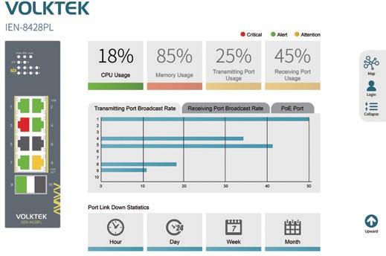
Dashboard
The dashboard is an intelligent system provides apparent views of real-time switch parameters in an engaging, easy-view format for the end-users. Dashboard’s at-a-glance designs with the color scheme enable the users for easy understanding and troubleshooting within the device and connected network.

Wizard
The wizard is a smart assistant who provides the switch setup interfaces for the users. It allows users to go through a series of well-defined steps with easily manageable dialog boxes. It minimizes the complex setup procedures and easier to perform for an unfamiliar user.




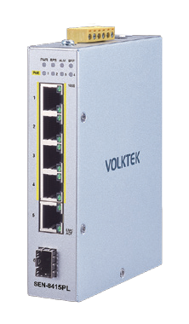
Robust Switch Performance

-10°C

60°C
Hot
Cold
With a hardened metal case, surge and ESD protection, the SEN-8428PL-24V provides a high level of immunity against electromagnetic interference and heavy electrical surges, thus facilitating easy deployment in demanding environments. In addition, the SEN-8428PL-24V offers high performance switch architecture with five 10/100/1000BASE-T ports and one 100FX/Gigabit Ethernet SFP slot to meet the requirements of high-bandwidth access in wide
operating temperatures.



DIN Rail to Power Adapter (AC to DC) & Terminal Block
The SEN-8415PL is ideal solution to prevent the failure of single power circuit, in which provides you options to facilitate the 802.3at High Power PoE usage. Either “DIN-Rail Power Adapter” to convert AC to DC for board operation in an easily and firmly installation with hardened connection to the switch unit OR “Terminal Block” which supports primary (PWR) and standby (RPS) can be used to powering PoE network. Categorized by its compact design, DIN-Rail Power Adapter can easily fit in smaller infrastructures and is extremely simple in installation. Saving your time and space, this adapter can be easily mounted next to switch unit in surveillance applications that have little space available. The second optional power supply through “Terminal Block” provides a low-cost, simple solution to the problem of an inadvertent failure of the internal power-supply, which can result in the shutdown of switching device, the PoE devices attached to its ports, or an entire network.


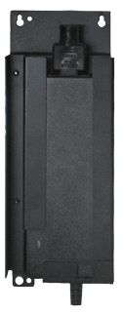
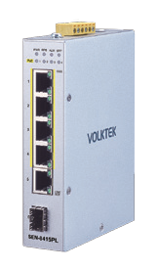

SEN-8415PL

DC

AC

2024~2025 Volktek Product Catalog
Features Highlight

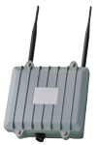

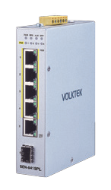
High-Power Budget for PoE Network Devices
PoE+
30W
Per Port
PoE
Wi-Fi AP
PoE
IP Camera
To fulfill the growing demand of high-bandwidth, high-power PoE for network applications and eliminating the cost of electrical cabling and circuits, the SEN-8415PL is designed under IEEE 802.3at standard PoE+. With 120W PoE power budget capability for whole system, the switch allows simple “plug-n-play” PoE for various types of high power consuming PoE devices. This makes the SEN-8415PL a very convenient solution for applications far away from power outlets satisfying PoE extension applications in much longer distances.



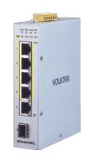

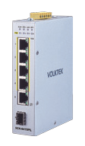
Intelligent PoE Alive Checking

PoE Camera
PoE Camera is “No Response!”

PoE Camera
“Restart” the PoE Device
Alive!
The SEN-8415PL is designed with intelligent PoE+ features to utilize power more efficient. To monitor real-time status of PDs, the switch sends alive-checking packets to PDs. If a PD fails to respond, the switch’s PD live check feature detects the failure and reactivates the PD. This reduces management burden and increases system reliability.

Simplified Installation w/ Compact Size
The SEN-8415PL provides varied choice of deployment locations even in small space, harsh environments, quick and easy installtion way by its compact size. Every SEN-8415PL is equipped with auto MDI/MDI-X on all ports for simple connection to other switches and hubs. When a compliant device is attached, the power supplied will automatically detect and classify to fit the device. With diagnostic LEDs panel, the SEN-8415PL allows you to know switch status and simplify troubleshooting.

Applications


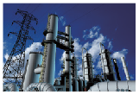



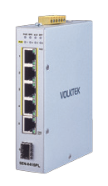



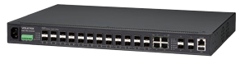
The SEN-8415PL combines high-power PoE+, robust
performance for surveillance systems in harsh
PoE
environments. With its compact size, highly reliable and secure features ensure continuous operations in some special requirements for transportation, factory and outdoor places where high vibration degree, shock
and wide range temperatures are present.
PoE
Client
PoE
PoE IP Cameras
PoE
PoE
NVR
Storage
PoE
PoE IP Cameras
RJ45
1000 Mbps Fiber Power + Data
PoE

Factory Surveillance

Building Surveillance

Traffic Surveillance

Standards
IEEE 802.3 | 10BASE-T
IEEE 802.3u | 100BASE-TX
IEEE 802.3ab | 1000BASE-T
IEEE 802.3u | 100BASE-FX
IEEE 802.3z | 1000BASE-SX/LX
IEEE 802.3 | Nway Auto-negotiation
IEEE 802.3x | Flow Control
IEEE 802.3az | Energy Efficient Ethernet (EEE)
IEEE 802.1AB | LLDP
IEEE 802.1D | STP
IEEE 802.1w | RSTP
IEEE 802.1p | Class of Service
IEEE 802.1Q | VLAN tagging
IEEE 802.1X | Port Authentication
Interface
Ports | 4 x 10/100/1000BASE-T (PoE+ RJ45)
Ports | 1 x 10/100/1000BASE-T RJ45
Ports | 1 x 100FX/GbE SFP
DIP Switch | Power voltage drop alarm setting (PWR & RPS)
LED Panel | PWR, RPS, ALM, SFP, PoE, 1000, LNK/ACT
Features
Performance | Jumbo frame Size: 10KBytes
Performance | MAC Table Entries: 8K
Performance | Switch Fabric: 12Gbps
Management | CLI, Telnet, SSH, HTTP, HTTPs, SNMP v1/v2c,  SNMP v3, SNMP Trap, Management VLAN (MVLAN), Firmware upgradable, Configuration Backup/Restore, Syslog, SNTP, LLDP, DHCP Client, Port Mirroring Server (service) control, Port Utilization,  Alarm Information, ModbusTCP, Power Down trap Topology Map, Dashboard, Installation Wizard Port Configuration (enable/disable,speed/duplex), ONVIF, Port Statistic, System reboot from remote side  User Account with authority
Reliability | STP/RSTP, ERPS v1/v2
VLAN | 802.1Q VLAN, Port-based VLAN (Port Isolation)
Traffic Control | 802.1p QoS, Flow Control, Traffic Monitor (Abnormal Traffic Detection),  Storm Control, Port Isolation, Loop Detection  Storm alarm threshold per port
Security | ACL (Access control list), Port Security (MAC limit) Port-based 802.1X, BPDU Guard  BPDU Filter, ROOT Guard, Trusted Managed Host
PoE/PoE+ | PoE Schedulng, PD Alive Check, PoE Power on/off, PoE Priority, Power budget control per system,  Power budget control per port, Power delay

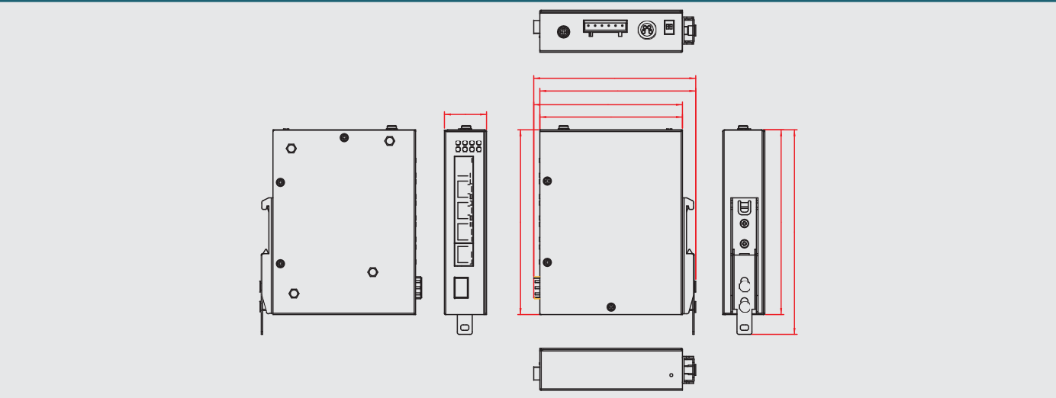
Dimension
31.00
119.30
114.80
109.50
105.00
Power
Input Voltage | Primary inputs: 48~57VDC
Input Voltage | Redundant inputs: 48~57VDC
Input Voltage | Mini DIN (4 pin): 48~57VDC
Connection | Terminal Block, Mini-DIN
Power Consumption | System: 10W
Power Consumption | PoE Power Budget: 120W
Alarm Relay | One relay output, 1A @ 24V DC
Mechanical and Environment
Housing | Metal (IP40 Protection)
Mounting | DIN-Rail
Operating Temperature | -10°C~60°C (14°F~140°F)
Storage Temperature | -40°C~85°C (-40°F~185°F)
Operating Humidity | 5 to 95% RH (non-condensing)
Storage Humidity | 5 to 95% RH (non-condensing)
Weight | 290 g (0.64 lb)
Dimension (WxHxD) | 31 x 136.3 x 105 mm (1.22 x 5.37 x 4.13 in)
Certifications
EMI | FCC Part 15 Subpart B Class A EN 55011 class A  EN 55032 class A EN 61000-6-4  ICES-003, ISSUE 7
EMS | EN 61000-6-2  EN 55035  EN 61000-4-2 (ESD)  EN 61000-4-3 (RS)  EN 61000-4-4 (Burst)  EN 61000-4-5 (Surge)  EN 61000-4-6 (CS)  EN 61000-4-8 (PFMF)
Shock | IEC 60068-2-27
Freefall | IEC 60068-2-32
Vibration | IEC 60068-2-6
Ordering Information

Lite Managed 4 x 10/100/1000 PoE+ &
SEN-8415PL
1 x 10/100/1000 RJ45 & 1 x FX/GbE SFP Switch
Optional Accessories
Power Supply | SDR-240-48: 240W DIN-Rail 48V DC Industrial  Power Supply, -25°C~70°C (-13°F~158°F)
GBM-104 | 1000BASE-SX 1.25G, Multi-mode SFP, 500 m
GBM-123TS | 1000BASE-LX, Bi-Di SFP TX:1310/RX:1550  Single Mode, 10 km, 0°C~70°C (32°F~158°F)
GBM-123RS | 1000BASE-LX, Bi-Di SFP TX:1550/RX:1310  Single Mode, 10 km, 0°C~70°C (32°F~158°F)
Note :
- The SFP communication distance upon the request.
- Industrial SFP with wide operating temperature from -40°C~85°C (-40°F~185°F) is available upon request.
- Specifications subject to change without notice.


2024~2025 Volktek Product Catalog
Specifications
136.30
136.30
150.90

